CS110 Project

Tic Tac Toe Game

Yichen Tao

Section B - 56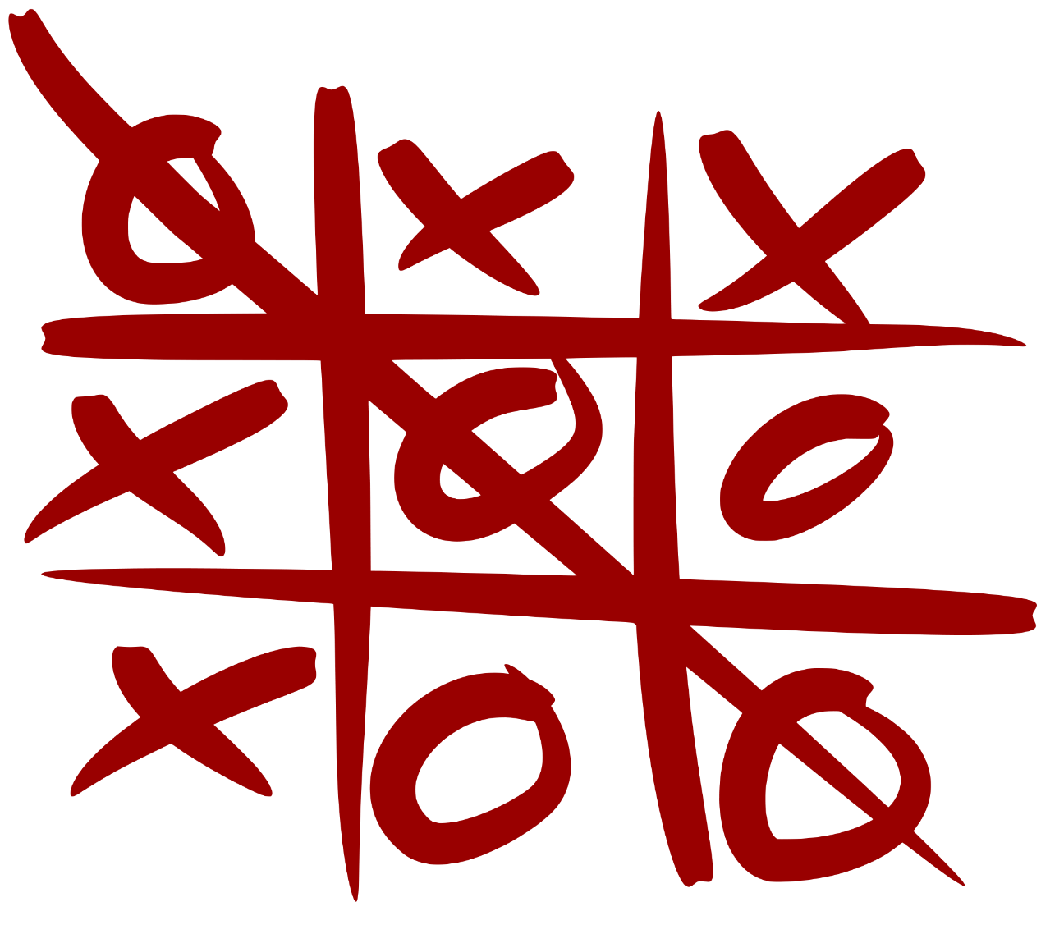

1. Main Screen – The game

When user click on set name button, a dialog window will pop up. User input in the dialog window to set names for players. This is optional.

Before playing the game, user will need to press set initiative button to decide which player will go first.

Then users can play the game.

When a player wins, a message window will pop up saying who is the winner.

